**Refresh using Expdp and IMPDP**

**Taking export of source schema**

1. Give input for dumpfiles,DB name and schema name as mentioned below,

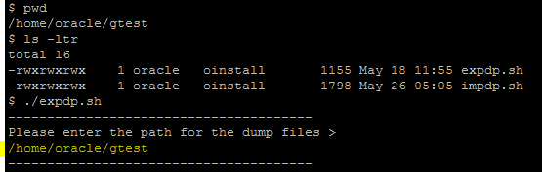

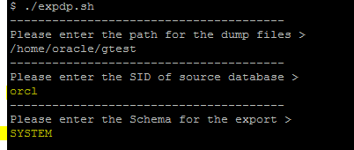

1. Script will create the directory automatically and create a shell script for export.

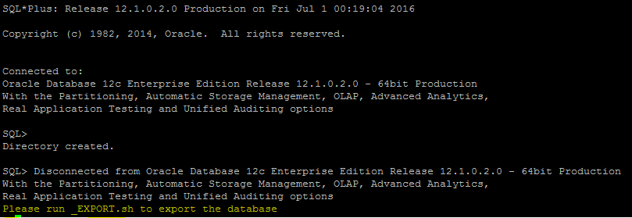

1. Execute the below shell script to start the export

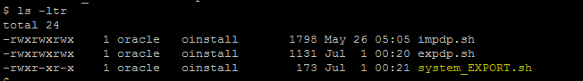



**For importing schema into target database**

1. Execute the impdp script and give all the input as mentioned below,

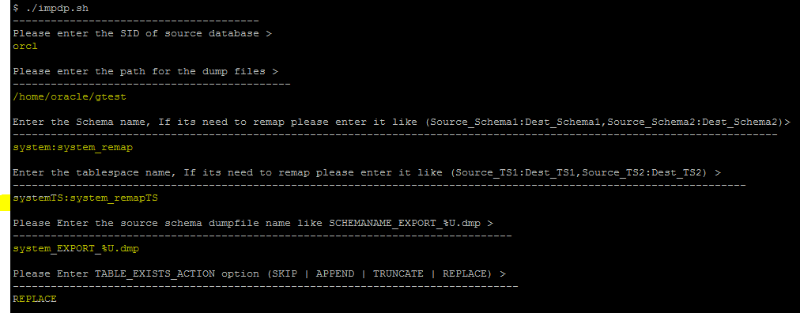

1. Based on the input dumps and directory, oracle will create generate a script

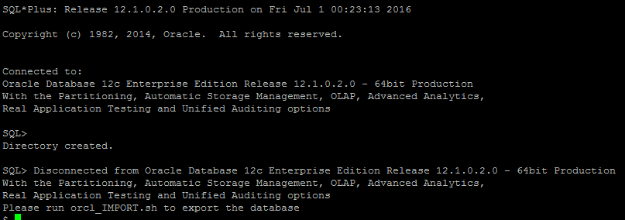

1. Execute the below shell script to start import.

